Hackathon – Project Life Cycle

Building An Inventory System

Project Overview

The project aims to develop a robust inventory system integrated with an e-commerce platform to facilitate efficient management of products. The system will include features such as user authentication, product listings, inventory tracking, order management, report, and analytics.

Objectives

* Develop a user-friendly interface for listing and managing products such as fruits and vegetables.
* Implement real-time inventory tracking and automated order management.
* Develop automated notification systems for order updates, low stock alerts, and returns management.
* Provide robust reporting and analytics modules for insights into sales and overall inventory performance.
* Seamlessly integrate with e-commerce platforms, suppliers, and forecasting tools.
* Ensure mobile accessibility and user permissions for secure data access.
* Enhance user experience with features like mobile accessibility and automated invoicing.

Planning Phase

Requirements Analysis

* Define user roles.

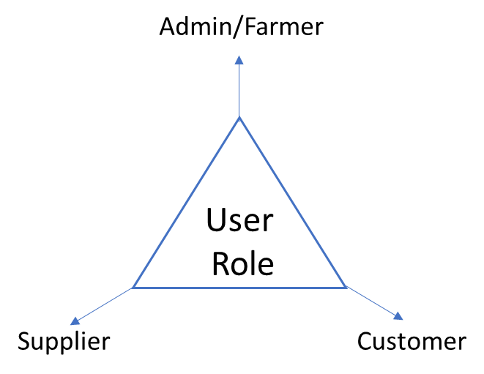

* Specify user authentication and registration processes.
* List features for product listings, inventory tracking, order management, and reporting.
* Define low stock alerts, automated order updates, and user permissions.
* Detail integration requirements with e-commerce platforms, suppliers, and accounting software.

Tech Stack Selection

* MySQL for database management.
* Python and Django for backend development.
* HTML and CSS for frontend development.
* Integration tools for connecting with e-commerce platforms.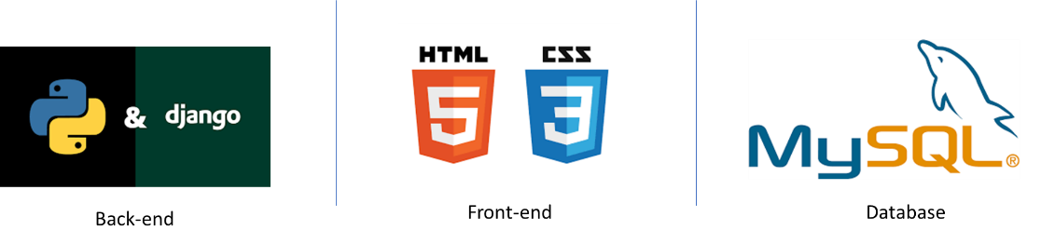

Design Phase

UML Diagrams

* Use Case Diagrams: Illustrate user interactions and system functionality.
* Activity Diagrams: Outline the flow of activities in various processes.
* Class Diagrams: Define the structure of the system’s classes and relationships.

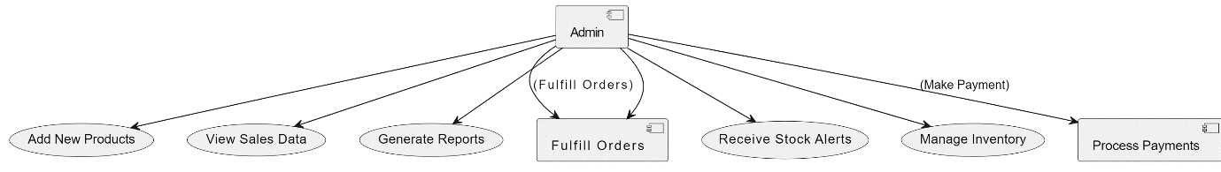

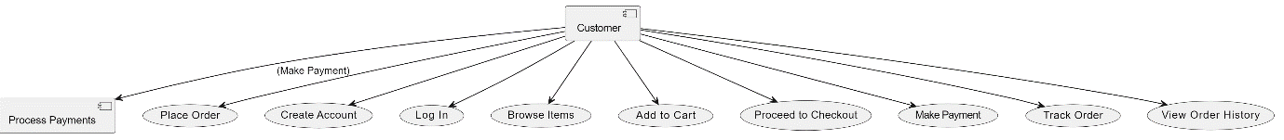

*Figure 1*: Use Case Diagram for Admin and Customer

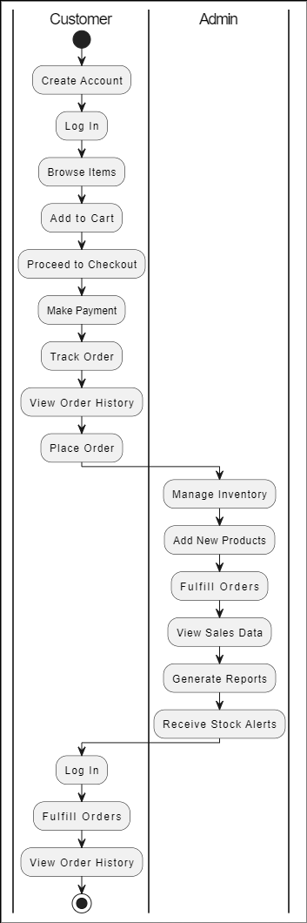

*Figure 2*: Activity Diagram

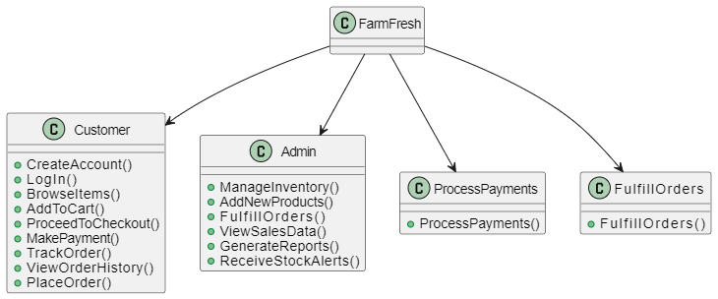

*Figure 3*: Class Diagram

Implementation Phase

Login/Register Module

* Develop login and registration screens with input validation.
* Implement account management features, including password change.

Inventory System

* Create product listing pages with details like name, description, price, and quantity.
* Develop real-time inventory tracking and order management functionalities.
* Implement automated order updates, low stock alerts, and reporting modules.

|  |  |  |  |  |
| --- | --- | --- | --- | --- |
| Pages | Product Listing | Inventory Tracking | Order Management | Analytics |
| Features | Product Name  Price  Quantity Available | Product Name  Price  Quantity Available  Quantity Sold  Sales  Stock Date  Last Sales Date | Track Customer Orders  Order Status (Pending, Shopped, Delivered)  Customer Details  Order History | Revenue generated  Top-selling Products  Trends |
|  |  | Add New Product  Update Product  Delete Product  Generate Sales Report | Order Confirmation  Shipping Updates  Delivery Confirmation |  |

Integration

* Integrate with e-commerce platforms.
* Implement automated invoicing.